Red Light Green Light
By: [Redacted]

Historically, baseball games have been very close in score–sometimes with one or two runs making the difference between victory or defeat. The idea behind this project is to increase the odds of winning by finding the best pattern for a baserunner to steal second base to bring the team closer to victory. Data was provided from SMT and was first filtered down to ball-events, lineups, and player-positioning. This was further taken down to positioning related to runner 1, runner 2, second baseman, and shortstop. Using Python, Machine Learning modeling in decision trees we found that defensive positioning and movement was the biggest indicator on whether a steal would succeed or fail. This model was tested on several different features and found the best predictor was defensive distance covered per step, velocity, acceleration, and jerk. Adding in runner data caused a data leak showing that the model is not predicating but already knows the answer so it has to be removed from testing. Next predicted information we used was catcher throw time seeing how fast the catcher could throw the ball to second baseman or shortstop. The catcher averaged a throw time of 2.42 secs to second baseman and 2.41 secs to shortstop with the success rate of stealing on the second baseman being 70.00% while the shortstop was 62.75%.

According to Team Ranks sports data there was a total of 4,475 steals attempted during the 2025 MLB seasons while this sounds like a lot but is only .70 steals per game. Steals are very rare during a game and when it does happen fans do not seem to care. I believe there is an untapped market for stealing. The problem that I hope to solve is how we can make stealing more exciting. The first idea that we used was making a machine learning model that can help teams attempt more successful steals. The second idea is using graphical design to make steals more exciting, increasing fan engagement. Using a decision tree to predict a success rate for some on first base if they decided to steal. I call this project Red Light Green Light Should He Go? Using machine learning on offensive and defensive positions to calculate the success rate of a baserunner stealing second base.

Using the data provided by SMT our first step was filtering where players were positioning themselves during a play or steal attempt. This was further filtered down to only runner 1, runner 2, second baseman, and short stop. After that only positioning data related to when some is on first base and adding in new columns that label True or False for is first or second is occupied. Using that info helped me isolate when someone was on first base but not on second and next play that person moved to second base with first base being empty. There is a high chance that this is a steal or maybe a double play. To further find if this was an actual steal the lineups data was added to get batter #. If first base is occupied then next play that person moves to second base and the batter # is the same a steal happened. This is enough to make a prediction on steals based on positioning data but adding in more data could be helpful and what better data then catcher throw time. Next, ball-event data was added filtering down plays to find a certain sequence of events to pitcher pitches, catcher catches, catcher throws, second baseman or shortstop catches. Using this data with timestamps from catcher throw to defensive catch we can figure out the throw time.

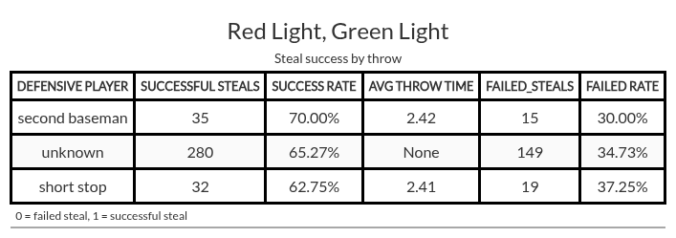

It was found that you have a higher success rate of stealing on the second baseman than the shortstop. The second baseman has 35 successful steals on him with an average throw to catch time of 2.42 seconds and the offense has a 70% chance of stealing on him. While the shortstop has 32 successful steals on him with an average throw to catch time of 2.41 seconds and the offense has a 62.75% chance of stealing on him. Plotting throw times on a density curve graph with the steal outcome measuring the peak density. Second baseman has around the same peak for successful or failed steal attempts being between 2.4 - 2.5 throw times. Shortstop had different density peaks with failed steals being between a throw time of 2.3 - 2.4 seconds and successful steals 2.4 - 2.5 seconds. This shows that half a second from catcher to defensive player can make a big difference between a successful or failed steal. Finally, adding in throw time into our dataframe we can now calculate offensive and defensive, change in position, run time, distance covered, velocity, acceleration, and jerk.
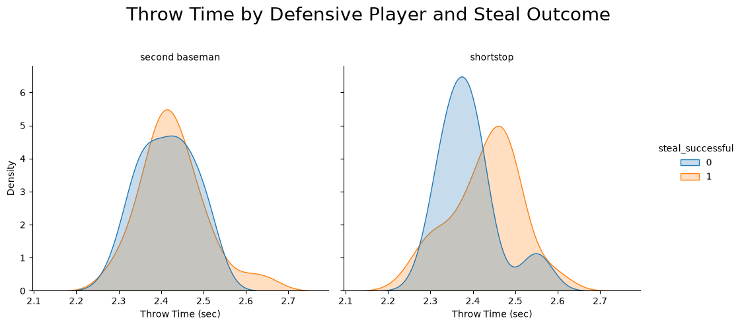

The model is used with machine learning to find a pattern of the best chance to steal using data we want to find y, the outcome that is being predicted which would be if a steal was successful. To find the predicted outcome x is used, which are features that can be used to predict y. These features are the columns we have collected. The current dataframe that was made has 24 feature columns to help predict y. Testing all these features is a time consuming process because there are over 1 million combinations which when tested will give a score of how well these features predict a steal outcome. Instead of hand typing all combinations a technique was used call forward feature selection that will test all features for us one at a time then print out the features with the highest score.

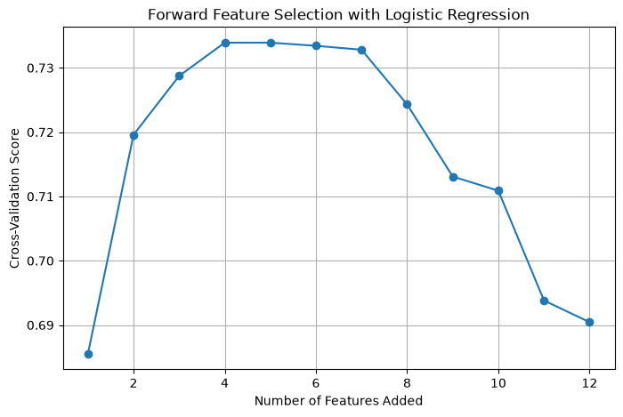
logistic regression is very similar to linear regression but while linear regression is used for testing numerical outcomes log regression is for categorical outcomes. The model slowly adds features together and assigns a score to each combination. In the graph above the highest score was four features at 0.734. Forward feature selection uses all features unless otherwise specified because of that a total of four different tests were done by removing some columns and any combination that showed a 100% score was automatically removed. These tests were tested on how well they can predict y if a steal was successful or failed. In this test we already know the answers but the machine doesn’t its job is to predict what the answer is then we tally up its score after that. In the first test only defensive columns were used and four features were chosen: defensive velocity, acceleration, distance covered per step, and jerk. Our model was 74% accurate when using these columns to predict steals. In the second test only base runner positioning was added and seven features were chosen: runner pos x, runner pos y, throw time, defensive jerk, defensive y, defensive distance covered per step, and defensive change in time. This one was 82% accurate but was not chosen as the final model because of test 3. Test 3 all runner features were added and six features were used: runner pos x, runner pos y, throw time, runner acceleration, defensive distance covered per step, and defensive change in time. This one used columns similarly to test 2 and had the same test score of 82% because of that test 2 and 3 were not used. For the final test 4. The 100% cap was removed and all columns were tested. What the cap does is stop the data from being leaked to the model which basically means the model can use these data points to cheat on the test knowing the answer instead of predicting it. Test 4 only four features are selected: runner pos y, runner pos x, runner velocity, and defensive distance covered per step. This has an accuracy of 100%.

Test_# | # of features | Feature list | Test score | Notes
1 | 4 | 'i_vel_defense', 'i_accel_defense', 'dcov_step_defense', 'i_jerk_defense' | 74% | Dropped all offensive columns
2 | 7 | 'runner_y', 'runner_x', 'throw_time', 'change_time_defense_sec', 'i_jerk_defense', 'defense_y', 'dcov_step_defense' | 82% | Left in offensive Positions
3 | 6 | 'runner_y', 'runner_x', 'throw_time', 'i_accel_runner', 'change_time_defense_sec', 'dcov_step_defense' | 82% | Left in all Offensive cols
4 | 4 | 'runner_y', 'i_vel_runner', 'runner_x', 'dcov_step_defense' | 100% | Removed Max Score

What originally started as a grand plan to increase steal chance and fan engagement turned into a simple flow chart. The highest predictor for a steal is how fast the second baseman or shortstop is. In the future, adding in ball positions to see the direction when the ball was caught and to further expand the model to include steals on third and home plate.

